**Executive Summary**

In this report, there are two websites were critiqued. From the reseach, it is obviously that interaction design is very important for a product. The Toyota website contains a large number of good designs, such as the effectiveness, memorablilty, feedback and consistency. But there are still some small problems about user experience. For the ASOS website, generally speaking, it could finish the function as a shopping website. However, there are many problems in this website. A lot of violations of users experience goals, usability goals, design principles and heuristics appear in this website. Therefore, every designer should focus on the interaction design, it would make the product more attractive and competitive.

**Intrudoction**

In the Internet Age, there are a large number of websites on the Internet and the user experience is more and more important. Therefore interaction design occupies a compulsory place in product designing. For this reason, This report will critique two websites, Toyota and ASOS. This analysis will focus on the interface of those two websites. It will refer to the Userability Goals, User Experience Goals, Design Principles and Heuristics.

**Description of Toyota**

This is the Toyota official website. The core function of this website is showing and selling the Toyota vehicles to customers. This part will fucos on the description of the functional aspects of the interface.

On the top of the view there is a menu bar, the purpose of it is classifying the main functions of this website. Users could get what they want because of the good classification of it. No matter the customers want to buy a vehicle online, find a nearest shop or know about the vehicle’s information such as the type and the price, they could find them easily by the good classification tabs.

Beneath the tab bars, there are some popular ranges of Toyota. The purpose of this part is showing different type of Toyota vehicles. This is one of the main functions of Toyota’s website. Furthermore, it also classifies the vehicles clearly, such as Cars&Minivan, Trucks and Crossovers&SUVs. Therefore, users could find their ideal cars by this part easily.

Some news appear below the Classification part. This part’s purpose is showing some Toyota’s information to users. Users could get some latest news about Toyota which is very useful for their purchasing. By this mean, this part could be attractive for the customer who have no requirement of buying a new car currently but just is a fan of Toyota. In addition, these news could be shown by gallery and list, it can be changed by users.

If users cannot find what they need, they could use the search function both on the top and the bottom of this website. Furthermore, there are already some key words in the bottom of the view which make searching much easier.

**Major findings of Toyota**

1. the “set location” function

This problem of this issue is about the user experience goal. When a user open this website, this dialog will alert the customer to enter his ZIP code (Pic1.1). This is a good idea to get the user’s location information. The designer also consider that if the users do not want to enter the code immediately, it will be disappeared after about 3 seconds so that it will not be annoying. The purpose of this design is good, but the designer did not consider if the user want to enter the ZIP code right now. When the users are entering the ZIP code, this dialog would also be disappeared after 3 seconds. So most of the customers can not finish it. By this mean, they should click “Set Location” and enter the ZIP code again. Therefore, it would make users unpleasant.

There is a good solution of this issue. If the user clicks the input view and is already entering the ZIP code, this dialog should not close automatically.

1. The feedback of select vehicles

If a user select “Featured”, there are three ranges vehicles. But when he moves the mouse on the pictures, there is no feedback (Pic 1.2). So this is not a good design. On contrast, when users choose the other options, they can find the feedback on the vehicles’ pictures (Pic 1.3). Therefore there are both positive and negative designs in this part.

1. Different display mode of news

There are many latest news in the website. This is a good design about “User control and freedom” which is one part of “Heuristics”. Because users could change the display mode (shown by gallery or list) as what they like. But a problem of effectiveness still exists. For most design the list should be smaller than gallery, because the main purpose of gallery is showing pictures. Thus if the users choose the display mode as gallery, they want to get some details by the picture. But if they choose list, that means they need to see more information. Therefore, this size of the item of list must be smaller than gallery so that the view could show more information to users. But in this website, list mode cannot show more news than gallery. So this function is not effective.

1. Good classification

The learnability of this website is very good because of the efficient classification on the menu bar. Users can know the function of this website clearly by this menu bar.

1. The share buttons

These buttons obey the rule of aesthetic and minimalist design. The designer only user the icon of different platforms of social networks to indicate the function of the share buttons. So they are simple and easy to be understood.

1. The checkbox of “show offer types”

It is a good example of “matching between system and the real world”. It looks like a switcher (Pic 1.4). Users could slide the button on the switcher to change the status of the checkbox. It is really like what we do in the real life. So it is also obey the usability goals (memorability).

1. The adaption of the website

When users change the window’s size of browser (Pic 1.6), the effectiveness of this view is quite bad and many of the functions cannot be used. Though the horizontal scroll bar is on the far right side, the position of menu bar is not changed. Thus customers can only use “Select Vehicle” and “Shopping Tools” these two tabs. By this mean, this website is rarely effective to use.

**Description of ASOS**

The main purpose of the website of ASOS is selling dress. It divides the customers into two different groups, men and women. Users could choose different kind of goods by this division.

In the center of the view, there is a picture shows the latest clearance information. But this picture is quite stupid. It makes this view like a flash games website, but not a shopping website.

Below this picture, a label says “free shipping* on orders over $30”. On this label, there is an airplane which could move with the movement of the scroll bar. But this function is quite useless. There are more than 10 buttons about “men” and “women” which make the view messy.

The bottom of the website is “discover”, while the classification is not good enough. The four divisions are not relative. Moreover, the pictures and the words are not relative either.

**Major findings of ASOS**

1. The big clearance picture in the center of the view

This picture is not obey one of the design principles, consistency (Consistency refers to designing interfaces to have similar operations and use similar elements for achieving similar tasks.). If users do not read the words on the picture, it is hard to recognize the view as a shopping website. It looks more like a games website such as flappy bird. For this reason, this is a bad design and makes users confused.

1. The feedback of every button

Every button on this website has feedback when the mouse move on it. It is a good design. By this design, users could know which one is clickable easily. In addition, if the network is in a low-speed situation, users could know they have already clicked the buttons. So it could avoid the repeated clicking.

1. The function of marketplace

This part is not consistent and effective. There is no relevant between the picture and the words (Pic 2.1). The words is about the marketplace, while the picture looks like the Men’s clothing. For this reason, if they change the picture to a building photo, it would be better. So for this part, consistency is the main problem.

1. The airplane on the “Free shipping” label

This airplane could move with the movement of vertical scroll bar. The designer may want to make the view interesting. While this design do not reach his purpose. This airplane is a little stupid because of the color and shape. It cannot make the user experience better. Sometimes it may make users confused if they do not understand the relationship between airplane and delivery. Therefore this is poor design.

**Accessibility Issues and Observations**

The accessibility is important for a website because it could help people with disabilities to participate in. In addition, accessibility also dose some benefits to people without disabilities. For instance, the website are flexible to meet different users’ requirements, preferences and some specific situations.

These two websites have both advantages and disadvantages in accessibility. Firstly, for the high-resolution screens, Toyota perform better than ASOS. There is no obvious difference in Toyota website between normal screens and retina screens. While the performance of ASOS on the high-resolution screen is quite bad because there are almost 50% blank area and the words is too small to read.

Secondly, because of the small font size, the website of ASOS is hard to people who have some optical troubles such as the seniors and the myopia. Though the text font size of Toyota is not big enough, good mapping and more pictures could solve this problem. People could know the functions judging by the pictures. But it would be better if the designer could make the text larger and clearer on the retina screens.

Thirdly, some users have trouble for typing. For example, the people who have single arm or broken arm, typing by the keyboard is difficult for them. Both of these 2 websites perform well for this situation. There are less input label and it is easy to finish most of the functions by mouse. Especially in Toyota, below the searching label, there are many keywords for common use. This is a very friendly design for these customers.

In conclusion, accessibility is an important key for the design of a website. Both the Toyota and ASOS have a good performance in accessibility, while they still need to be improved.

**General Trends and Overall Recommendations**

The interaction design become more and more important with the popularization of Internet. Because there are many choices for users, designers must consider more about the user experience of their products so that they could be attractive and comfortable.

A good interaction design should follow the Design Principles, User Experience Goals, Usability Goals and Heuristics. These two websites have both benefits and shortages in interaction design. According to the research of these two interfaces, there are some general trends could be summarized. On the one side, both of them have good feedback (issue 2 & issue 9). It could make users know whether the operation they have done goes into effect. On the other side, issue 7 and many issues about ASOS have the problems in user experience. They make users unpleasant and uncomfortable. Therefore designers should try to improve the website so that the user experience could be better.

There are some recommendations about the interaction design, For Toyota, the whole design is good, but adding feedback for every button could make the user experience better. The ASOS should focus on accessibility because the adaption for high-resolution screen is bad. Furthermore, the website should follow the principle of aesthetic and minimalist design.

**References**

Sharp H, Rogers Y and Preece J (2011) Interaction Design: Beyond Human-Computer Interaction, 3rd Edition, John Wiley, England

**Appendix**

1. Scenarios
2. James is a student of UNSW. He lives very far away from UNSW so he intends to buy a cheap minivan. He open the website of Toyota. But because he just know little about cars, he cannot decide which one he should choose. So he clicks the tab “Select Vehicle” and chooses Yaris. There are much information appears on the website. He read the information carefully and have some opinions about this car. When he has finished reading, he finds there is a button says “Compare Models & View Specs” on the bottom of the view. He clicks i and finds there are some different models of the car. After comparing all of them, he makes a decision finally. He will buy a Yaris 5-Door L.
3. Iris is student of University of Sydney. She wants to buy some pairs of shoes. So she opens the ASOS website. There is an obvious button says “view women”. She clicks this button and select the footwear. All the shoes are displayed on the screen. And then according to the filter which contains color, heel height, brand, price range and size. She finds 3 ideal pairs of shoes and add all of them to bag. After that she clicks bag and is going to pay for them. However when she presses “pay securely now”, she finds that the signing in is compulsory, there is no way to buy without an account. So she feels disappointed and gives up this shopping experience.
4. Issues Tables

|  |  |  |  |
| --- | --- | --- | --- |
| 1 | the “set location” function | unpleasant | negative |
| 2 | The feedback of select vehicles | feedback | Positive & negative |
| 3 | Different display mode of news | User control and freedom | Positive & negative |
| 4 | Good classification | learnability | positive |
| 5 | The share buttons | aesthetic and minimalist design | positive |
| 6 | The checkbox of “show offer types” | matching between system and the real world | positive |
| 7 | The adaption of the website | effectiveness | negative |
| 8 | The big clearance picture in the center of the view | consistency | negative |
| 9 | The feedback of every button | feedback | positive |
| 10 | The function of marketplace | Consistency | negative |
| 11 | The airplane on the “Free shipping” label | cutesy | negative |

1. Annotated Sketches and/or Annotated Screenshots

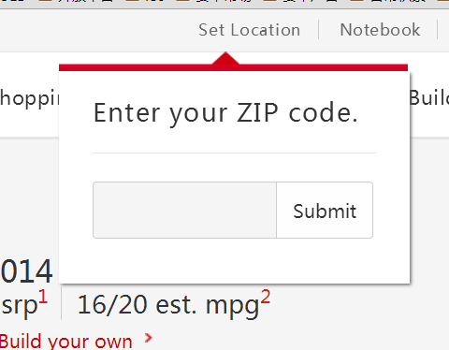

Pic1.1

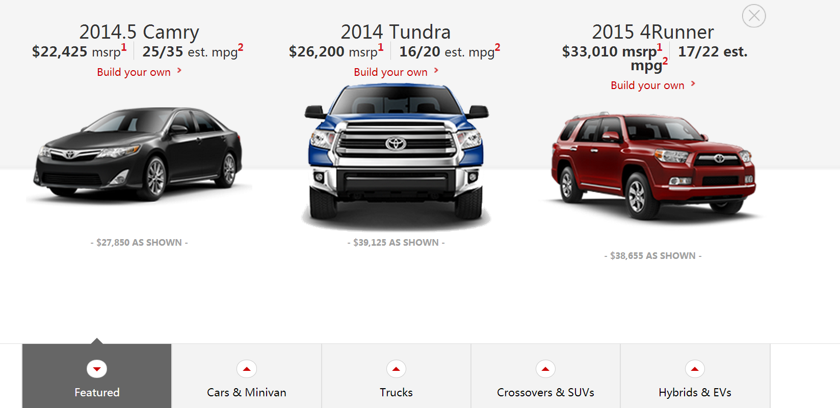

Pic1.2

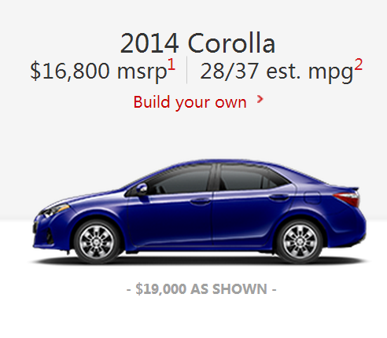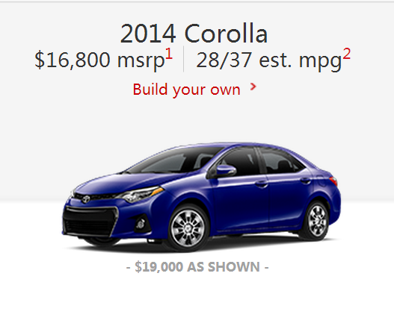

Pic1.3





Pic1.4

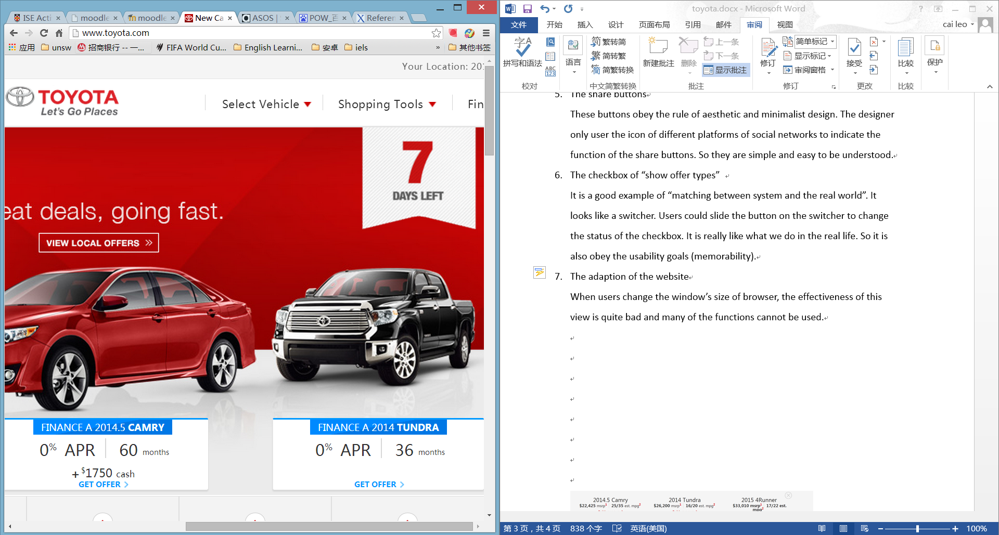

Pic1.5

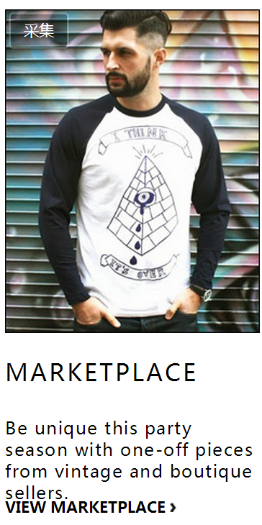

Pic2.1